**Table of contents**

1. Our project

1.1 Background ----------------------------------------------------------------------------------------------- P. 2

1.2 Meeting the needs of the end user ------------------------------------------------------------------ P. 3

1.3 Product evolution ---------------------------------------------------------------------------------------- P. 4

1.4 Problems encountered and how we overcame them ------------------------------------------- P. 9

1.5 Sustainability measurements ---------------------------------------------------------------------- P. 10

1. User feedback

2.1 Curriculum mock sessions --------------------------------------------------------------------------- P. 11

2.2 Cooking workshops ----------------------------------------------------------------------------------- P. 14

2.3 Curriculum design feedback from advisors ----------------------------------------------------- P. 17

2.4 Feedback from partners ------------------------------------------------------------------------------ P. 22

1. Future plans

3.1 Plans to do user testing and obtain feedback -------------------------------------------------- P. 26

3.2 Future plans --------------------------------------------------------------------------------------------- P. 27

3.3 Timeline for the coming months -------------------------------------------------------------------- P. 27

3.4 Program execution, training and maintenance ------------------------------------------------- P. 29

1. Our project

1.1 Background - Cultural, Social and Economic:

**Social Dynamics:**

From discussions and back and forth communications with our partner, we realized that the social fabric of the Dang community is very solid. The dynamics resemble those of a family, most are related by blood and/or have very close relationships with one another.

**Economic Activity and migration:**

The tribal communities of the Dang District account for 90 % of the inhabitants. Their main economic activity is agriculture: seasonal, mostly rainfed crops like Ragi, formerly their main staple food along with white rice. The lack of long-term consistency forces the community to migrate to far sugar canes for a period of 4 to 8 months annually.

**Dietary Habits:**

These communities follow a mostly vegetarian diet, relying on their home-grown products and using white rice as the main staple. Here you can see the percentage of some produce's consumption by tribe: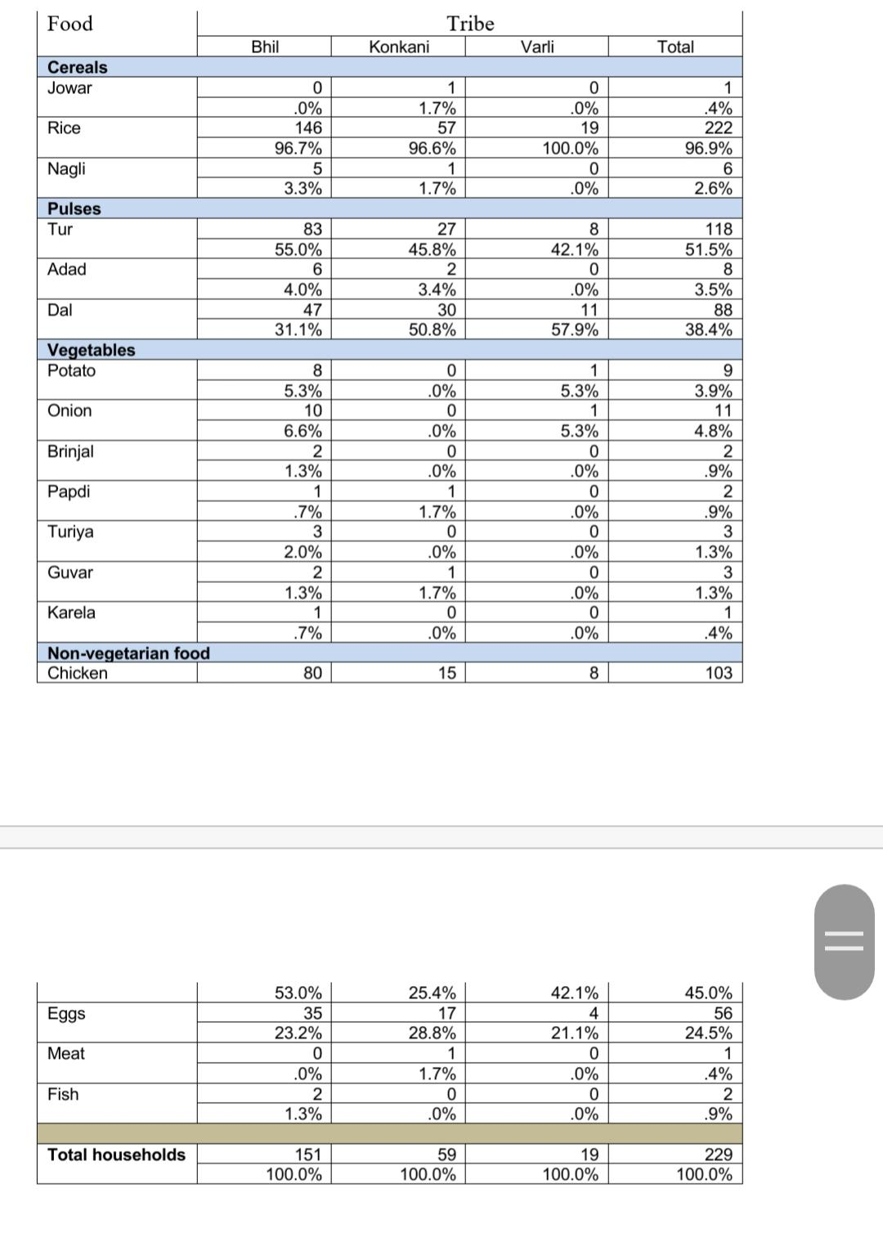



vegetables , although local are rarely consumed by Dang families ,and onions take the lead by 6.6% within the Bhil tribe. Chicken and eggs are the most consumed animal products.

**Anaemia:**

The prevalence of anaemia is very high mostly among children and women , over 70 %.

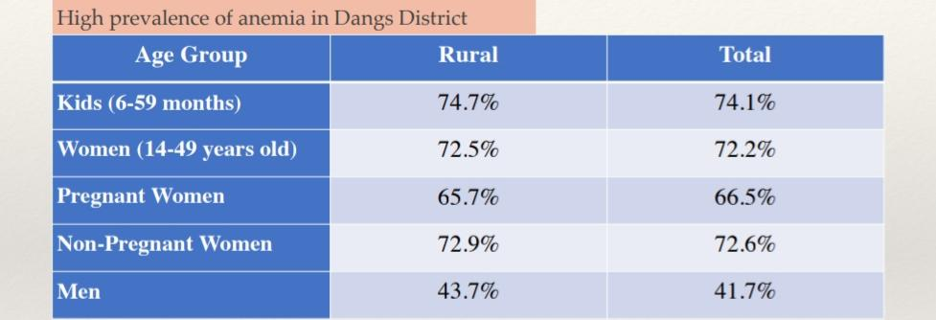

Retrieved from: Ministry of Health and Family Welfare, Government of India. (2015-16) National Family Health Survey (NFHS-4).

1.2 Meeting the needs of the end users:

**The solution:**

We have found our solution on the core idea that to make impact within a community, we need to first understand its cultural specificities and to make the community a part and enactor of the implementation following participatory solutions and to enable the population to look for solutions using local resources.

Behavioral changes as a target:

The passive approach to food consumption, and the lack of awareness on the disease , healthy diet and how to choose local, accessible ingredients to boost the iron content of a recipe were our main focus when we chose to work on the educational front.

**Meeting the needs of the end user:**

To tackle anemia, we designed a curriculum to educate the local students. By teaching them the knowledge of anemia, including the common symptoms, possible causes, we could raise their awareness of anemia. Secondly, the food making session and courses on healthy diet could notify them of the treatments. They can improve their conditions by having the knowledge of the right food and the cooking methods.

On the educational materials design, we chose an user-friendly approach. We are aware of the difficulties of the content and the language barriers, so we design the materials mainly with illustrations and posters. Also, to attract and motivate the students, the way we teach and the content have to be appealing. Meaning that we have to stand in the viewpoints of a 13-15-year-old student. The stories are related to their daily lives and the ingredients are locally available. This way, the students can truly relate themselves to anemia and the treatments. For example, what it will possibly be like when they are anemic? How does it affect them? And how can they improve the condition? Once they know the importance of anemia and what anemia is to them, they can be motivated and participate more in the courses, instead of cramming the knowledge we provide. We believe by holding educational camps with knowledgeable courses and cooking workshops that are related to the students, it will not only raise their awareness but also learn more effectively on how to improve the conditions.

1.3 Product Evolution

**Teaching activities**

At first when we tried to design the curriculum, we planned to make it into consecutive workshops in four days, each day having its own topic and food making recipe. However, we later saw it as something not effective because we want to reach as many people as possible, even if it is still in a very early stage. With normal workshops, students have to go back to their houses, so there is no guarantee for them to come back after their first workshop, which will affect the way we assess them as well. If we really want to reach those from different villages, then we should come there by ourselves, arranging a new session of the workshops, but it is impossible due to time constraints and the amount of arrangements needed to be made.

For those reasons, we decided to incorporate the workshops in a camp setting that runs for 3 days in a row. This will allow students from different areas to stay overnight, which will ensure constant attendance numbers. As the schedule becomes more compact, it is also easier for us to focus more on putting necessary details. Below, you can see the previous arrangement (top) and the camp one (bottom). It is clear that the one on the bottom is more organised and also includes other activities that can hopefully keep the students entertained and build closer relationships between students and teachers.

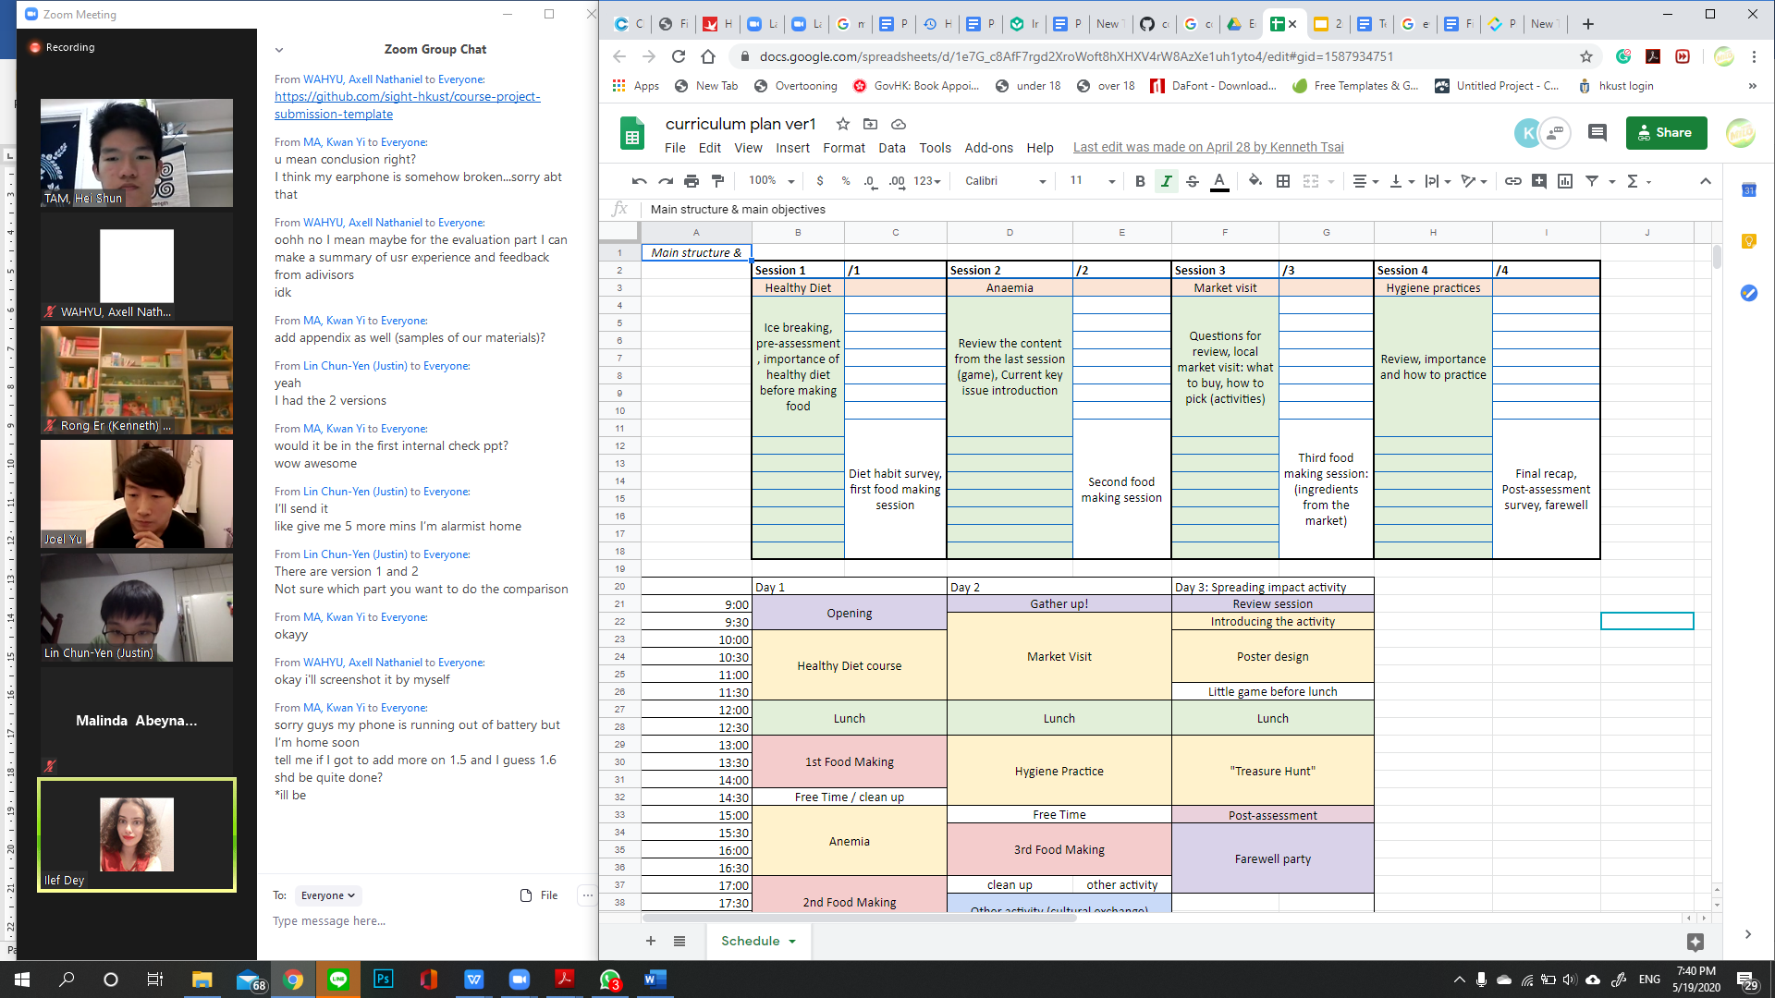

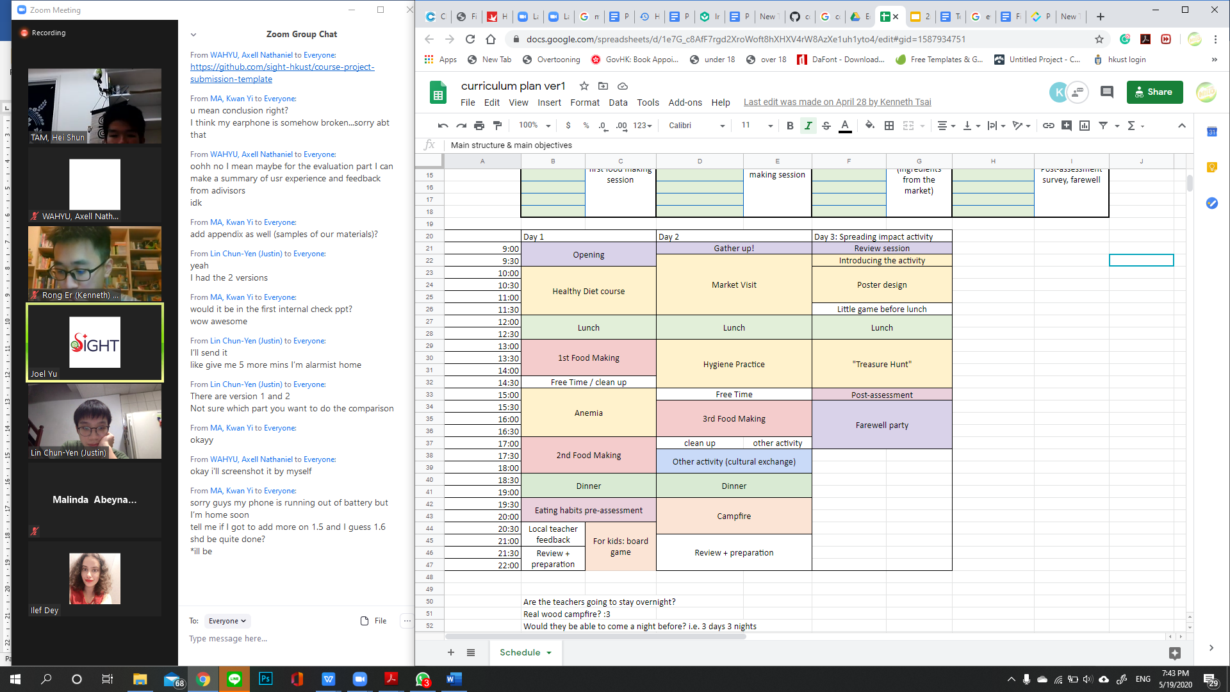

Some considerations should be made when making the curriculum as the situation in Dang District is different from schools or communities in the cities that we are familiar with. For instance, there are not many technologies available there, so instead of using presentation slides that require a projector to be delivered, we decided to use printed posters, pictures, and other conventional tools as the supporting tool. We choose this because posters are relatively cheap to produce and easy to carry and distribute to different places, but most importantly, it is not hard for the local teachers to get used to it.

As the poster is only used for the actual teaching activity, additional teaching guidelines for the teacher needs to be made. The teaching guidelines’ purpose is to help the teachers to conduct the classes, without having the need to attend our camp in person. This will give them more independence which allows the spread of practice. Throughout the process of making the guidelines, we faced many comments on how to improve them:

1. **Lecture notes and activities**

At the beginning of the process, we made the teaching guidelines similar to what a lecture notes is. The contents were put in sequences of where to start the teaching and what the materials are. However, it does not explain how the teaching mode is going to be, so it will be difficult for someone who has never seen the guidelines to try to teach from it.

Some activities were also put in different parts of the guidelines, containing what the activity is going to be with some written goals that we want to achieve after. This was not enough because there should be more details, such as, the instructions of the activity, supporting materials to use, how to deliver the rules, and so on. Adjustments need to be made for first timers to understand how to conduct the overall class.

1. **Incorporating additional details of the activities**

After receiving feedback from our advisors, we decided to put more considerations on details to make it clearer for the teacher. For instance, during a game activity, we specifically mention the subsections of the game and their durations: dividing the children into groups of 5 or 6 randomly, delivering the game instructions, how to play the games, and what to do after the game finishes. This is crucial for the teachers to be able to manage their time accordingly, so that the session will not overrun.

Here are some screenshots of the comparison between the before (left) and after (right). Even under the same activity (teaching), we put more explanations under each sub-activity.

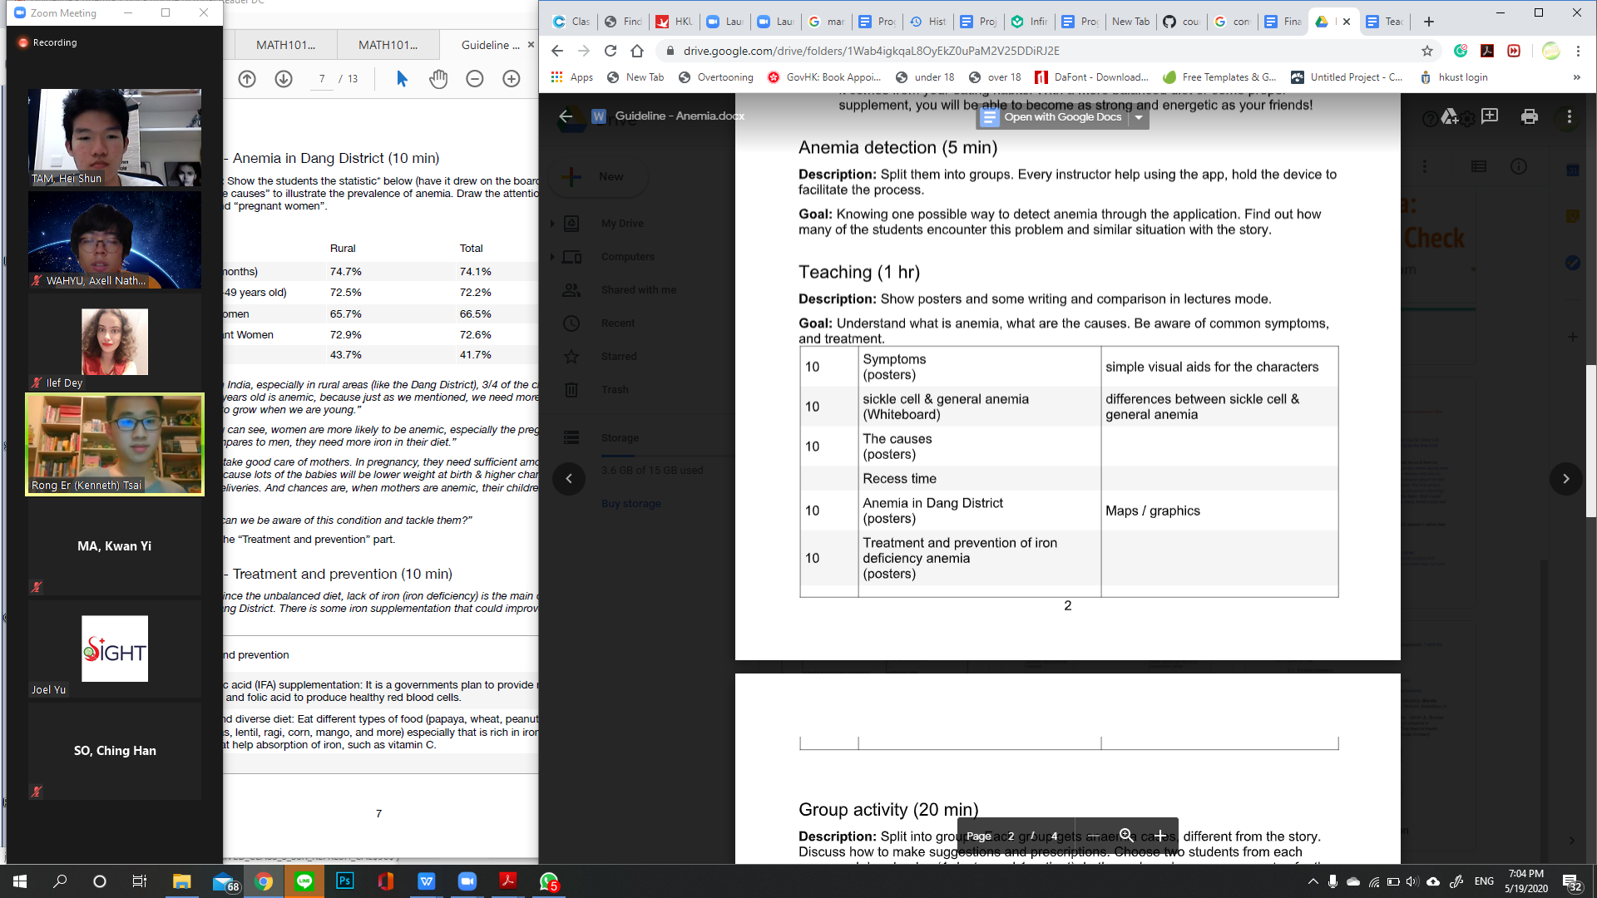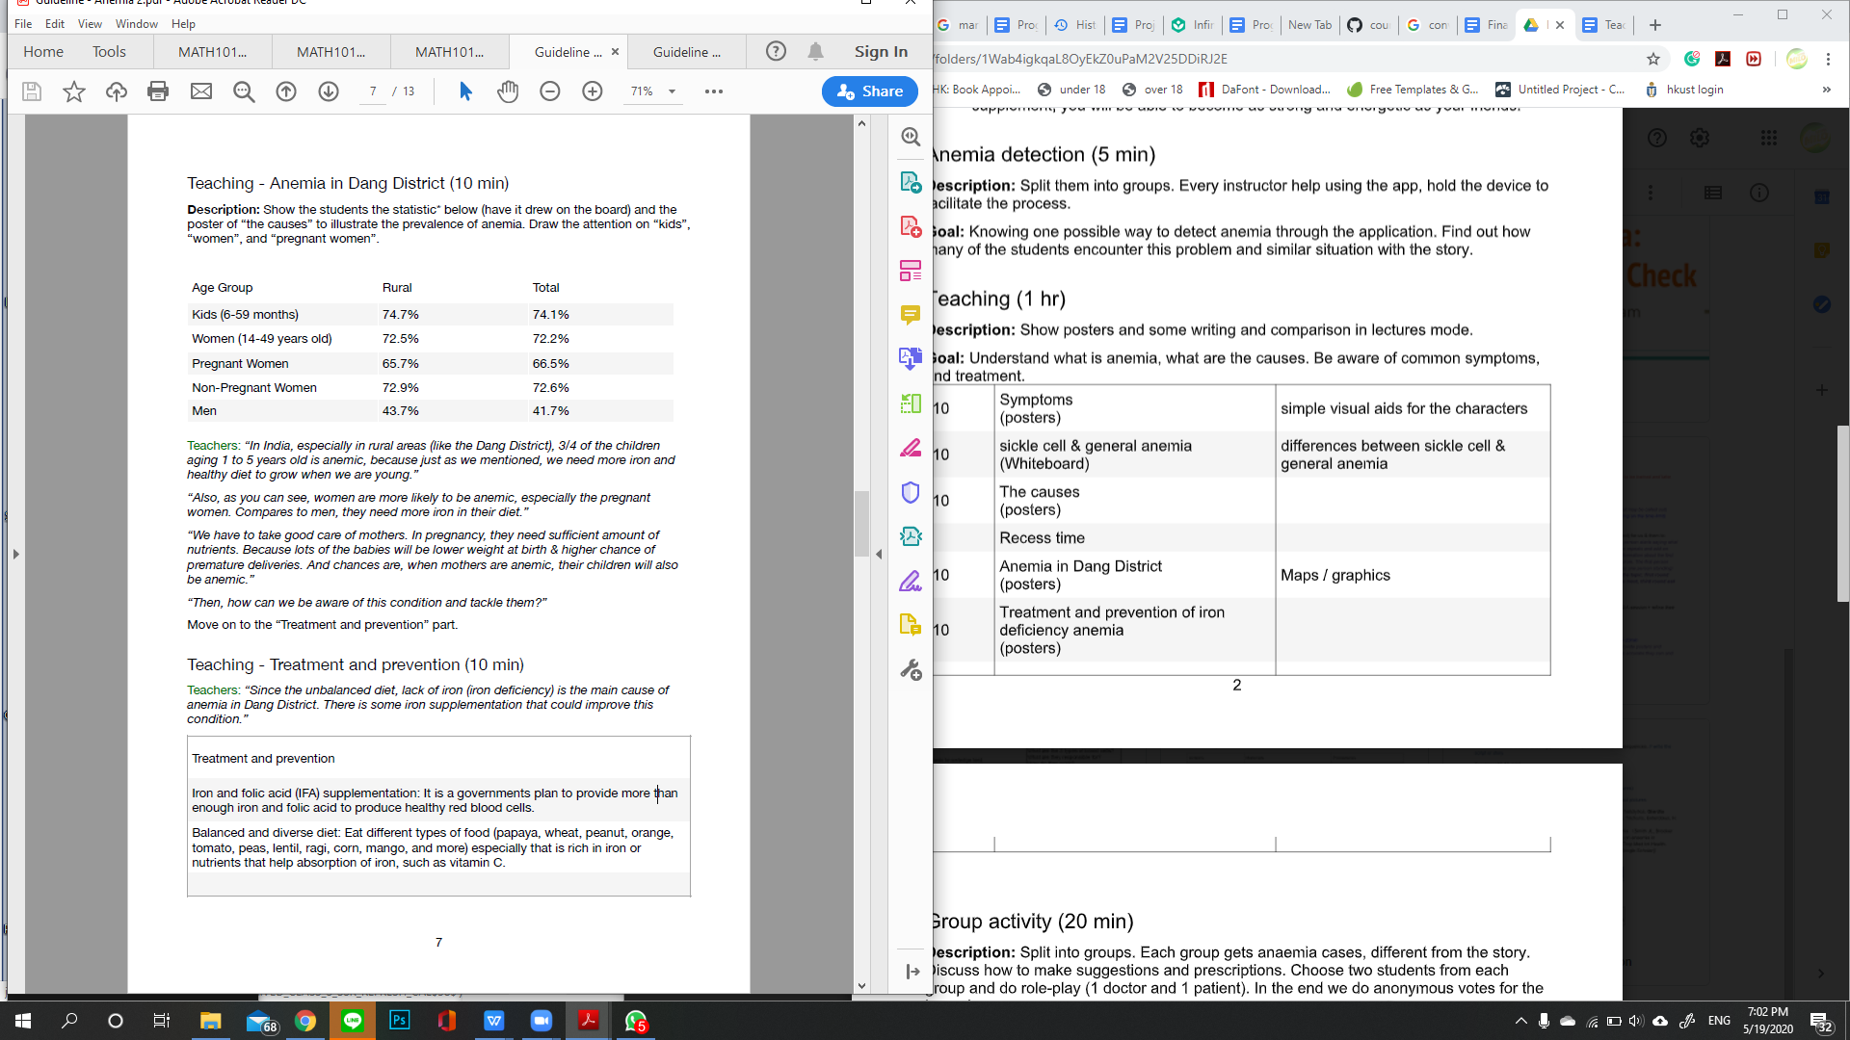

Some separated lecture notes are also provided for the teachers to look at for extra materials. This will hopefully complement the materials in the teaching guidelines that allows the teacher to understand the topics better without distractions of details regarding how to conduct other activities. Additional materials are also included to give them a bigger picture and possibly cover some questions or details that are not included in the teaching guidelines.

1. **Engaging activities and Q&A**

Despite having those changes, the teaching guidelines were still lacking in terms of providing engaging activities, especially on the teaching parts. This is because the teaching part was designed to be delivered from one way only: teacher to student, which might not be a good idea since the children are still young with relatively short attention spans and possibly still very new to the topics they are about to receive. To deal with this problem, we incorporated many Q&A sessions for the students to stay active throughout the class. Games that are directly related to the topics were also made, so that the students have their interest.

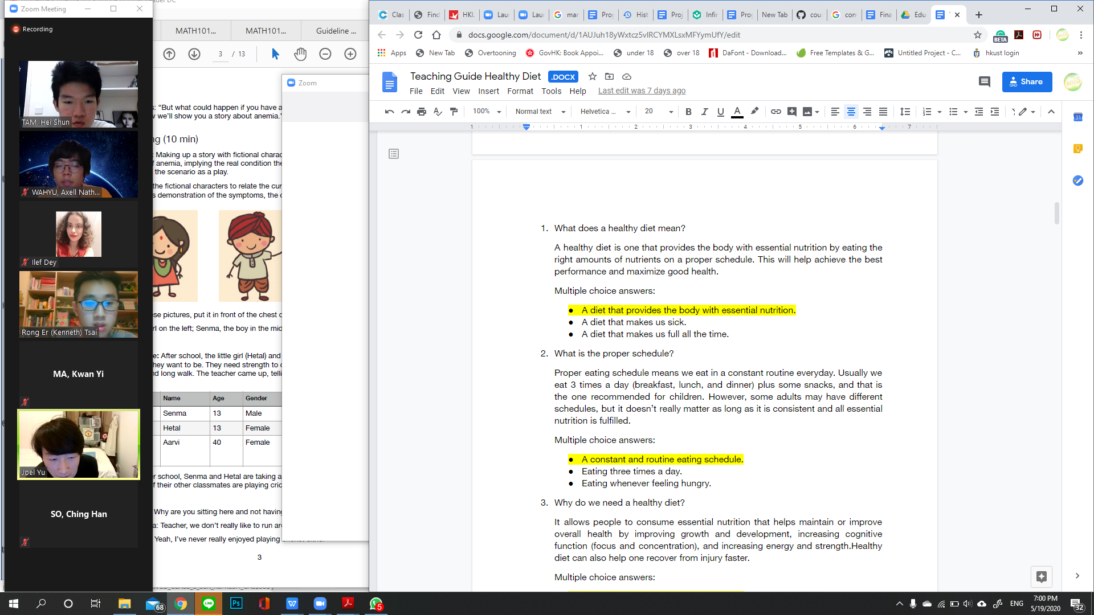

1. **Delivery to relate with real-life problems**

Some additional notes that we received is that, despite students actively participating in those activities, they might still not retain the information if they cannot relate to that information. So, we made some activities, mainly related to storytelling to give a real-life example of the problem. For instance, in the anemia teaching guideline, there is this section where a role play will be held about students suffering anemia and how the teacher helps them on how to deal with the situation. There is also storytelling in the healthy diet section about superheroes that acts as the nutritions related to iron-deficiency anemia. These stories will later be used on exercises and teaching activities to ease students when trying to relate the topics with their own experience.

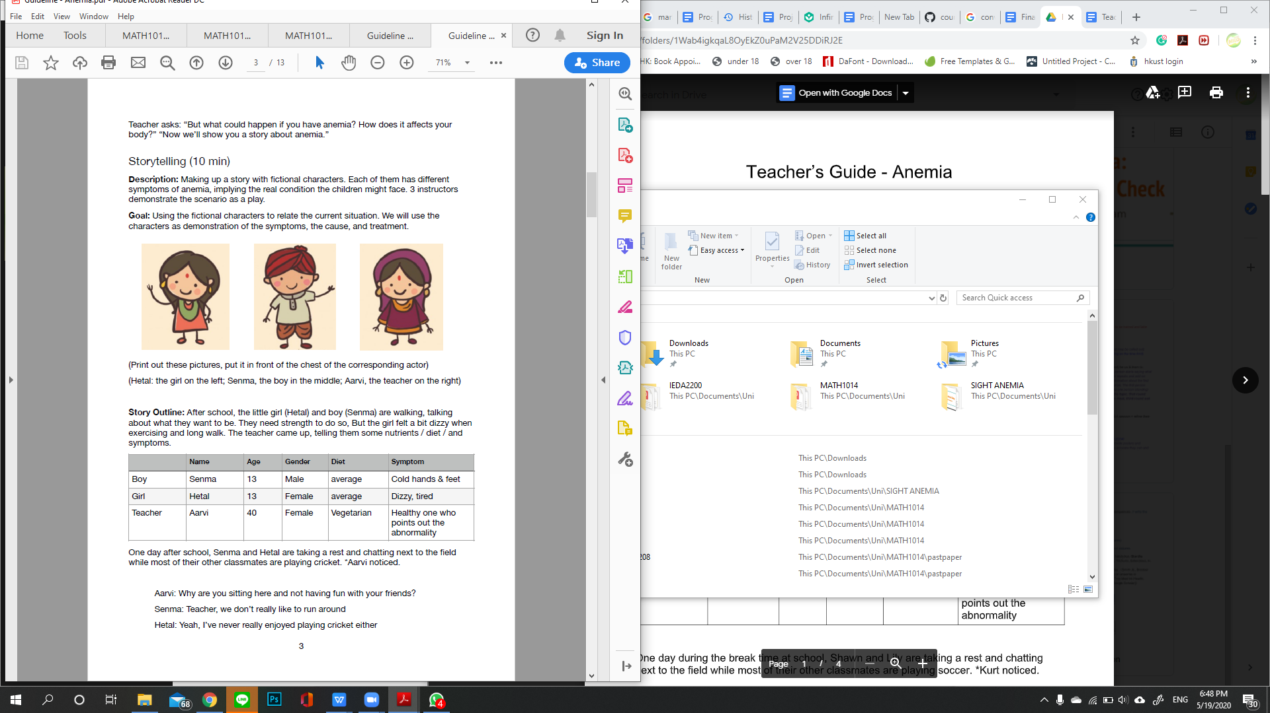

**Recipes**

**a. From snack to a diet plan**

In the beginning of the project, our team has decided to design an iron-rich snack in hope to tackle the anaemia problem of the children in Dangs. However, after some research and discussion, the villagers in Dangs have a low iron daily diet with nearly no food diversity. Therefore, our team has switched to proposing a diet plan to change the eating habits of the villagers, because a diet plan can provide more suggestions of recipes and introduce them to some ingredients that are rich in iron, which helps in blood production, and vitamin C, which enhances the iron absorption. After some research, our team has finalized on the choice of dishes to include in our diet plan, which are dhuli mung dal, parantha and chikki which Mr Rajesh has kindly introduced to us.

**b. modifications to increase iron content and absorption**

· Dhuli mung dal

Dhuli mung dal is an Indian spiced lentil soup. Lentil is rich in iron, however, iron content varies among different kinds of lentils. Urad dal and masoor dal, which are black and red lentils, contains more iron than mung dal, therefore we have changed to urad dal or masoor dal in our recipe. Also, the recipe includes high vitamin C ingredients such as tomato and onions, to help enhance the iron absorption.

· Parantha

Parantha is an Indian flatbread made of wheat flour. In our recipe, we use rajgira flour instead of wheat flour, because rajgira flour has a higher iron content and is as well available in Dangs. We have also included the use of lentils, urad dal and masoor dal, to increase the iron content. Moreover, we also added spinach leaves and onions in our recipes to increase vitamin C content.

· Chikki

Chikki is an Indian sweet peanut snack. Jaggery and peanuts are used in the recipes, both have high iron content. Nuts and seeds such as groundnuts are rich in iron, therefore, are recommended to use in the recipes.

**c. Nutritional values of the final products**

With the main purpose of tackling anaemia with the recipes, our finalized recipes in the diet plan are able to provide sufficient iron to the villagers.

The recommended iron intake for children aged 9-13 is 8mg1[1]. Taking the average iron bioavailability for mixed diet, the required iron bioavailability is 1.8mg.

Iron bioavailability per portion of the recipes:

* dhuli mung dal: 0.56mg (44% of daily requirement)
* parantha: 0.77mg (60% of daily requirement)
* chikki: 0.627mg (49% of daily requirement)

**Curriculum**

After many adjustments, we see that our teaching guidelines have reached a stage where it is appropriate enough to use. The format is detailed enough to let someone who sees it for the first time be able to teach from the guidelines only. Despite being detailed, we will emphasize that this is not a strict set of rules that has to be followed, since local teachers might know better how to communicate with their students or what games are more interactive or commonly known by the children there.

The purpose of these guidelines is so that the teachers get inspired from certain activities and be able to know which specific materials needed to be covered when the next workshop starts. These guidelines can also easily be distributed to different people in different places, which hopefully will widen the reaching range and bring impact to more people in the future.

1.4 Problems encountered and how we overcame them

In the beginning, our group was discrete and did not have a common goal to reach. We were so stubborn to focus on minor issues such that we almost made no progress for the first few weeks. To address this issue that we noticed, we changed our centre of focus from only drafting outlines, to actually finish each prototype one after one. Shortly we built the core of the course outline and the overview of the camp, then moved on to complete all the materials smoothly.

After we finished and presented our first draft, we received a lot of negative feedback from the teaching team. They pointed out that we were only at a planning level, which lacked detailed execution strategies. We thus modified the courses by adding more step-by-step instructions to the teaching guideline, stating the goal for each section clearly, and providing separate documents for all the teaching materials. Meanwhile, we kept in touch with Mr Rajesh for the details to make sure the feasibility of our plan. To test out the potential flaws in our plan and to gain practical experience, we ran a simulated practice with a grade 8 student. We kept refining our education plan, and finalised it a week before the roadshow.

Our project’s highlight is the cooking workshop, but that is no easy task to finalize the recipes. We had to make several modifications to the recipes to maximize the iron content while ensuring the food suits their preference. To tackle it, we collected data of the viable ingredients in Dang, their local market price and nutrient value of the ingredients. We confirmed with Mr. Rajesh about our findings and asked him for recommendations. These data make ease for our decision thus we are able to make our first draft swiftly.

Some problems popped up as we tried to cook the recipes ourselves. For instance, the required ratio of water and jaggery of the chikki differs with different types of jaggery. It took quite a number of tries to confirm the amount needed. We understood that we cannot rely on one cooking video only, so we spent time studying a lot of other cooking videos. It paid off for us to get the right amount of ingredients and to provide the right expectation as we were testing the recipes ourselves.

1.5 Sustainability measurements

To ensure the sustainability of the program, our team has taken actions on a few main perspectives.

1. **Carefully designed user friendly materials**

We have designed our curriculum outlines clearly and easy to use. Our team also made detailed documents on how to conduct every step of every class, down to the details of each activity and every cohesion-building game. The users of the guidelines (any teachers) will be able to navigate through the course. In other words, the teaching guidelines are self-sustainable and will allow for the potential to be used in different settings.

1. **Special activities for exhibiting an act of inspiring others**

We added a lot of functions in our program that facilitates the willingness of our students to promote the concept of anaemia towards the community. Examples would be our highlighted event, Market Visit and Treasure Hunt. During the Market Visit, students can capture the full picture about the crops by actually seeing and touching them during a walkthrough guide followed by a “buy your own ingredients” task. This can solidify their knowledge and provide a hands-on experience of buying nutritious products. For the Treasure Hunt, students would have the opportunity to reach out to the community and spread the information they have learnt, pitching people to pursue healthy habits as they do. By doing so, we encourage them to step out of their comfort zone and to exhibit an act on account of continuity.

1. **Maintaining close connection with the local teachers/translators to fit our materials into local context**

Our team is closely in touch with the local translator(s) who we have been updating every step of the progress since the beginning of the curriculum construction. This not only allows us to fit into the local cultural context, but it also helps set expectations for the local students’ preliminary knowledge on relevant topics.

1. **Actively connecting with outside NGOs for expansion and sustainability**

Since this is technically a one-off project, we tried to reach out to third parties for passing down our ideas and beliefs. Around a month ago, we started to connect with another local NGO called PATH, which honoured the common goals with us. In the latest meeting, we have agreed to work together to ensure the expansion of our target reach and they have promised us to introduce our project to other organizations and the local government. In return, our project will also serve as a platform for them to promote their product “fortified rice” by including it as part of our curriculum.

Additionally, to ensure the quality of our curriculum plan, we have also made sure to collect feedback from the students right before the camp is over (details as shown in “post-assessment”).

**5.** **Selecting student ambassadors to teach in subsequent sessions**

For the cooking workshops, during the first contact with students, we try to understand who possesses cooking skills or is used to participating in house chores, particularly, cooking.

Then, during the cooking workshop, we take a few steps of the cooking and ask students to participate, for instance, chopping onions or adding the proper spices, the ones that do an acceptable work can earn badges for the specific task( like the scouts way).

At the end of the second workshop, we count the badges earned by each student and those who got a certain number will be our assistant in the third workshop : cooking parantha, a dish they are most familiar with. We will focus on teaching them how to be more independent and assist students in learning.

These students will become ambassadors, work as assistants in the succeeding versions, spread the word about our program and recruit other children from the district.

2. User Feedback

2.1 Curriculum mock sessions

To carry out plans for the testing of our curriculum, we have managed a mock zoom teaching session. He is a local Hong Konger who does not speak much English, and here is the process and some key takeaways from the experience:

We have invited a 14-year-old to help us to the testing. First, we started off by teaching Ilef, who does not work on designing curriculum directly. This is to imitate communicating to the local teacher, and then Ilef moved on to teach the kid while we were her assistants.

**Evaluation points:**

1. how well can we communicate the curriculum to the local teacher

2. how understandable is the curriculum to the local teacher

3. how well does the kid respond to our content design

**Key issues identified:**

* The flow was very disrupted, it could be because of the translation and the kids’ shyness
* Some of the questions can get a little awkward when they really don’t know anything, but maybe in a group competition setting it would be better?
  + We can make some of the questions into MC once the open ended questions don't work
  + If MC still doesn't work then we pull out visual aids
* Might need to take out some of the more difficult words, as the audience might be intimidated by the hard words, difficult to translate too
* Need to prepare the document even better
* Some of the moments might not be deliver as well because we are referring back to the first class
* It got a lot better at the end when we used Mandarin to deliver, even though we still had to translate most of the time

We also obtained feedback from people taking up different roles in the mock session:

* Kid:
  + Less words, more pictures, more interesting examples (those are what the kid remembered), more interaction will be appreciated
* Observers:
  + The speed can be slower and with intervals for the interpreter to speak
  + Better if the interpreter knows the curriculum in advance so the flow would be smoother
  + We want more focus on the things they will remember: pictures, visual aids, maybe we can draw a little boy with symptoms on the spot
  + We want to make sure some of the words are emphasized (anemia)
* Teacher:
  + The language barrier was very limiting in the teaching experience.
  + All the material must be translated
  + The material offered to the children and those to assist the teacher should be separated
  + The teaching exercise offered to teachers must include a more extensive background on the disease for their own understanding and filling the knowledge gaps for them, not just geared towards teaching the kids

**Our response:**

1. Color coding for the curriculum to increase readability:

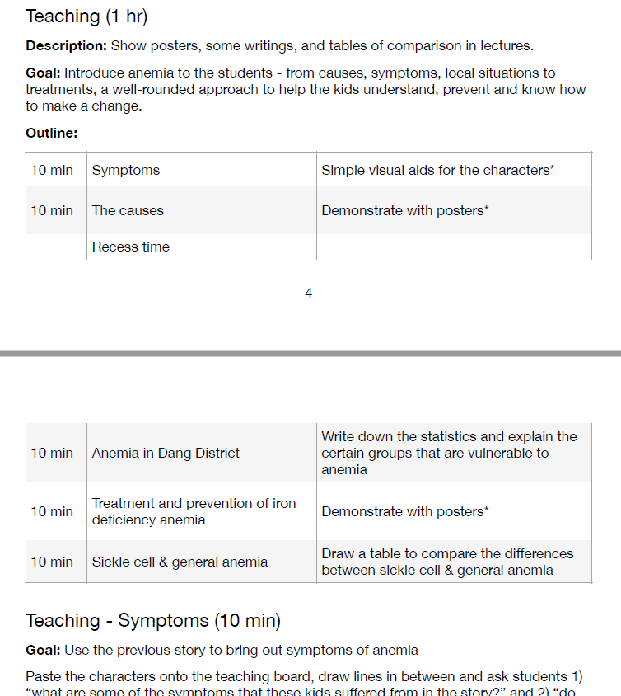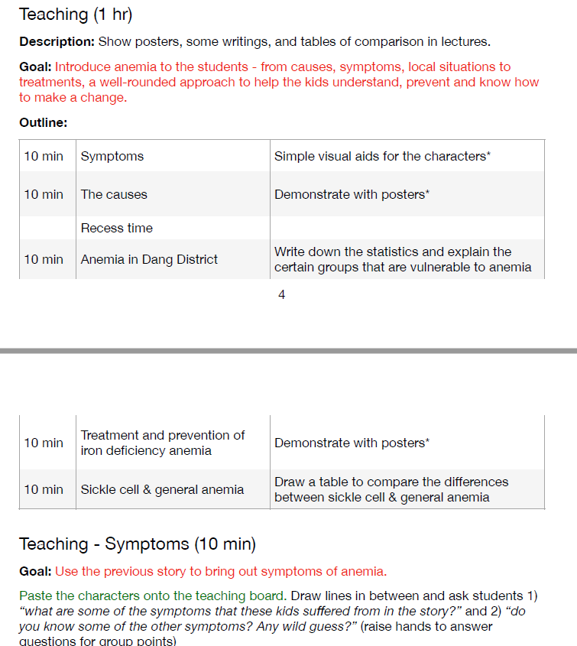

1. Multiple choices for the questions asked in class to avoid awkward silence when the kids do not know the answers

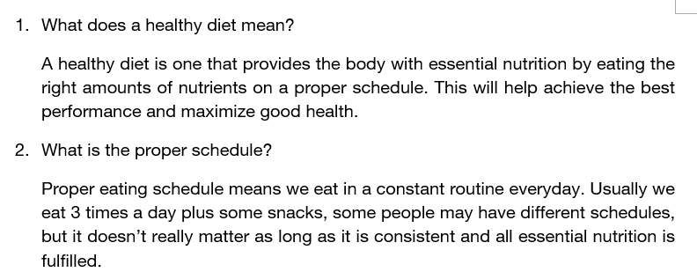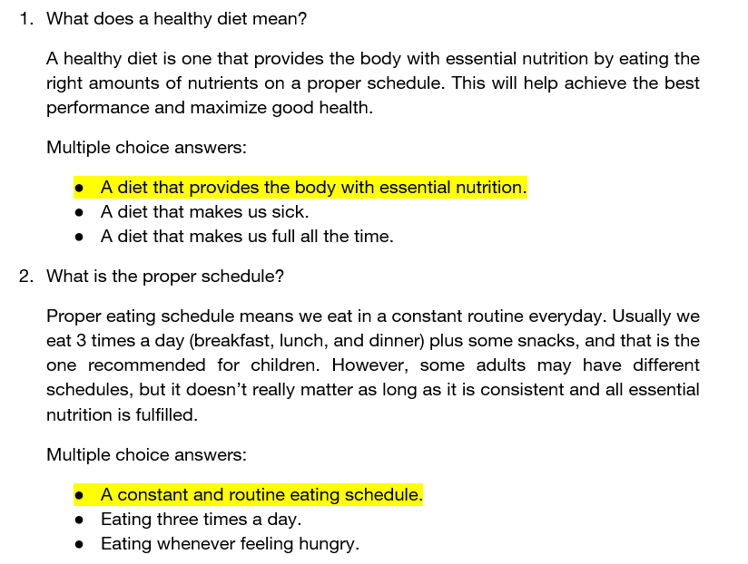

1. Even with content-heavy sections, it’s essential that we keep things interesting. by adding more visual aids and examples.

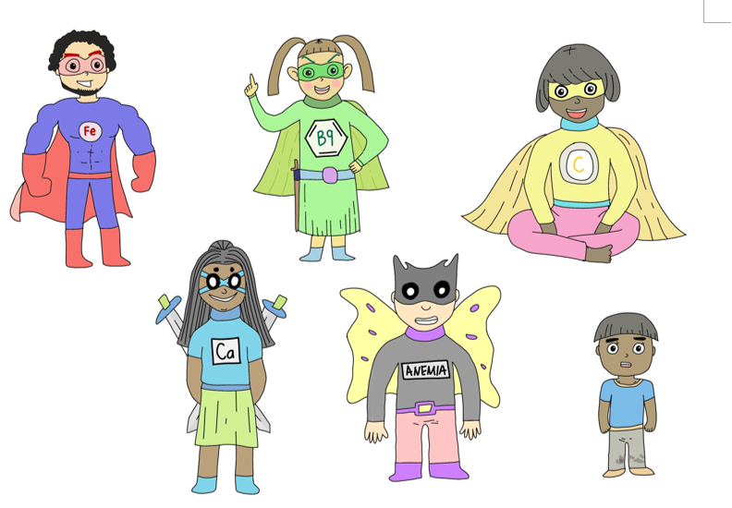Characters in a storytelling session

**Notes:**

A lot more of the mock-sessions need to be carried out, and our team has yet had the time to refine every single curriculum to the level of details (in terms of the materials, visual aids, examples etc) that the final product needs, so that will be one of our main focus over the next period of the project.

2.2 Cooking workshops:

**2.2.1 Food making:**

We received the feedback from Prof. Sujarta that parantha needs wheat flour in order to make it into a dough, or we can substitute the wheat flour with potato or egg. So in the prototyping video, we try to add rajgira flour (which is high in iron content) and potatoes to make the parantha. And it turns out successful.

**2.2.2 Workshop conducting:**

a. Hardware

There are several concerns for us when we are planning our flow of cooking workshops as we expect that the equipment there will be less advanced than in the urban area. At the beginning we received pictures from our partner with very traditional cooking settings as they are less developed, so we try to choose our recipe with the least cook utensils and skills needed. For example, parantha only needs a pan to cook it which will be easier for us to do the demonstration. And our partner informed us that he could provide us with the portable gas stove which will be much easier for us to conduct the whole workshop as we will be more familiar with the use of it.

However, due to the limitations of the hardware, we could only conduct the cooking workshop by demonstrating steps to the students. We will let the students try out different steps of cooking to escalate their interest and attention in the whole workshop.

b. Prototypes and trials

As suggested by the teaching team, trials and prototypes are needed to investigate the challenges and difficulties we might encounter during the cooking sections. Therefore, we tried to make chikki and parantha by ourselves to see if there are any things we need to be aware of. On our first attempt to make the chikki, we put the chikki into a freezer thinking that the chikki would condense quicker, but it turned out to be too hard to cut. We understand that the chikki has to be put at room temperature in order to solidify the jaggery. These discoveries could certainly make our food-making process become smoother.

And the pre-recorded video will be preferred as we have language barrier with the local students, it would be better if we let the interpreters to familiarize the process of our cooking workshops so they could translate the content more efficiently.

c. Taste of the food

Due to the current situation, we did not have much chance to serve it to Indians to understand local preference, instead we let our friends and family to try it.

For the dhuli mung dal, we were not able to get all the ingredients from any source, for that we did not try it. We will try it out during the summertime.

For the chikki, after making sure the chikki is set under room temperature and has the correct ratio of jaggery and water. The chikki is crunchy and the sweetness of it is appropriate. However, the colour of the chikki is too dark comparing to what we expect, possibly due to the type of jaggery we used, more tries on that is needed

For the parantha, on the first try, we put too much cumin seeds and the amount of flour is insufficient. Due to that, the taste of the cumin seeds overwhelms other ingredients and the parantha is dry and is not sticking well. On our last attempt, we doubled the amount of spinach and onions, used less cumin seeds and put an egg in. This time the parantha has great colour and the taste of the vegetables is standing out, the portion is sufficient for one meal as well. But the parantha is a type of bread in Indian culture, while ours looks like an omelette. We might need to rearrange our recipes to better suit in the local culture.

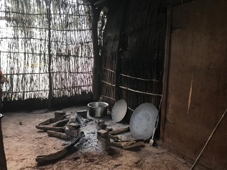

Picture we received from our partner.

**2.2.3 Evaluation:**

From the suggestion of the teaching team, evaluation of the effectiveness of our program is needed so we can assess how effective our cooking workshop is. So we have made a Food Frequency Questionnaire to check the students’ eating habits before and after the workshops.

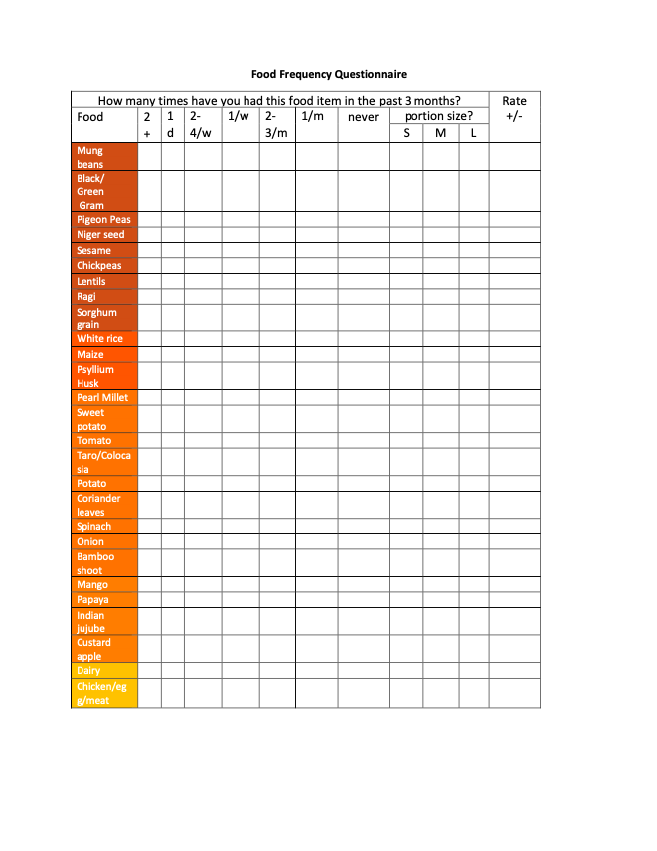

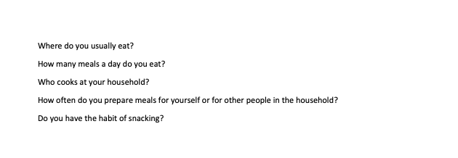

2.3 Curriculum design feedback from advisors

Feedback from Prof. Sujata Visaria on May 5th:

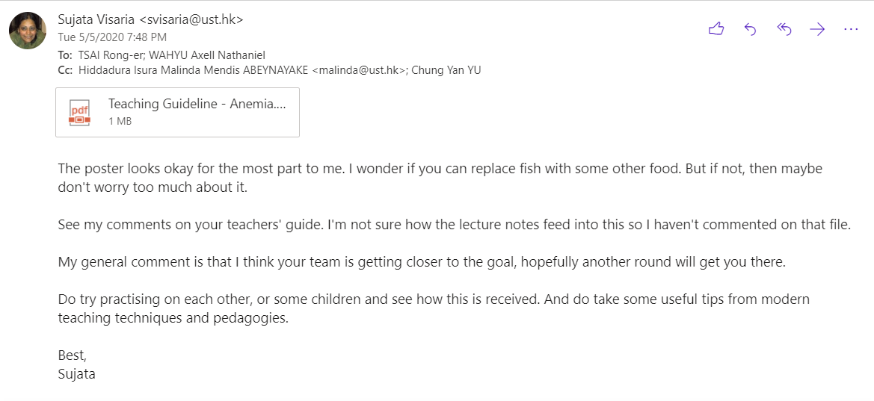

The key comments within the curriculum can be categorized into three:

1. The content has to be very culturally appropriate, and that includes the characters we design, the names we use, and the level of knowledge that they may have obtained at school prior to our camp.
2. Instead of presenting facts to the local kids, the curriculum has to focus on how to relate the content to the kids. There is a difference between “here are the facts, remember them and you will do well in a test” versus “here is why this is relevant to you, learn from me and you will find it useful in your life”.
3. Be mindful of the kids’ ability to write. Even if they are literate, it does not equal being able to express quickly and effectively.

Feedback for post-assessment survey design (from Prof. Sujata Visaria, Apr. 25):

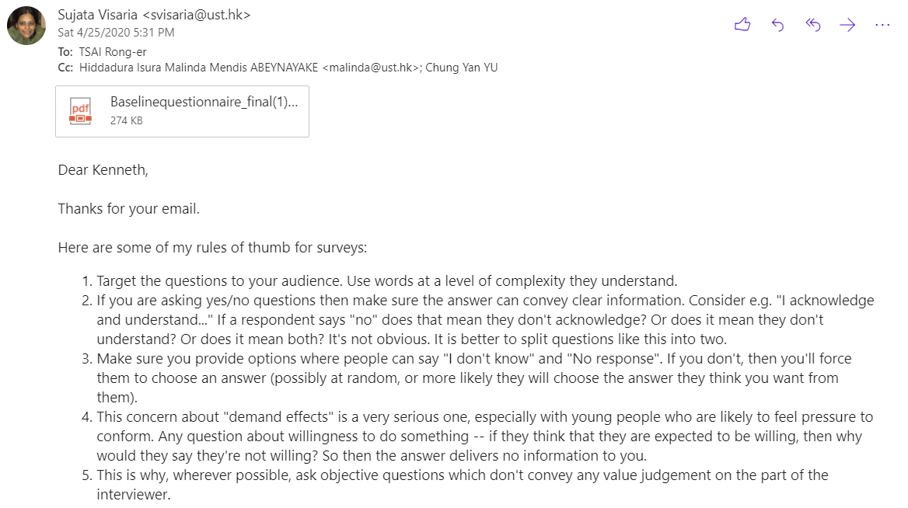

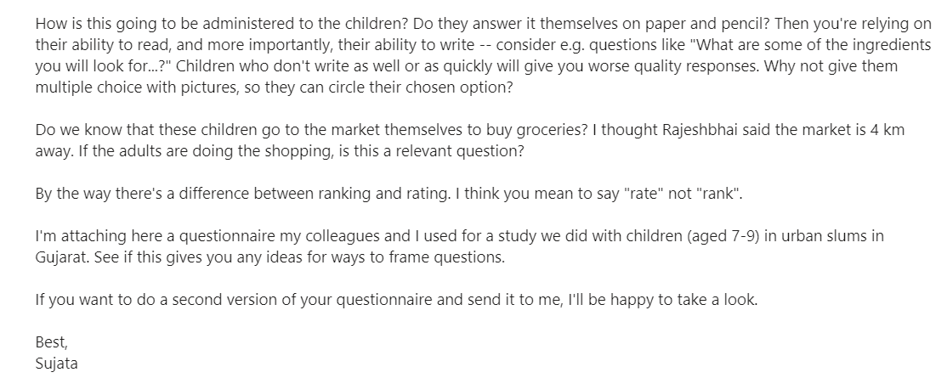

Our follow up:

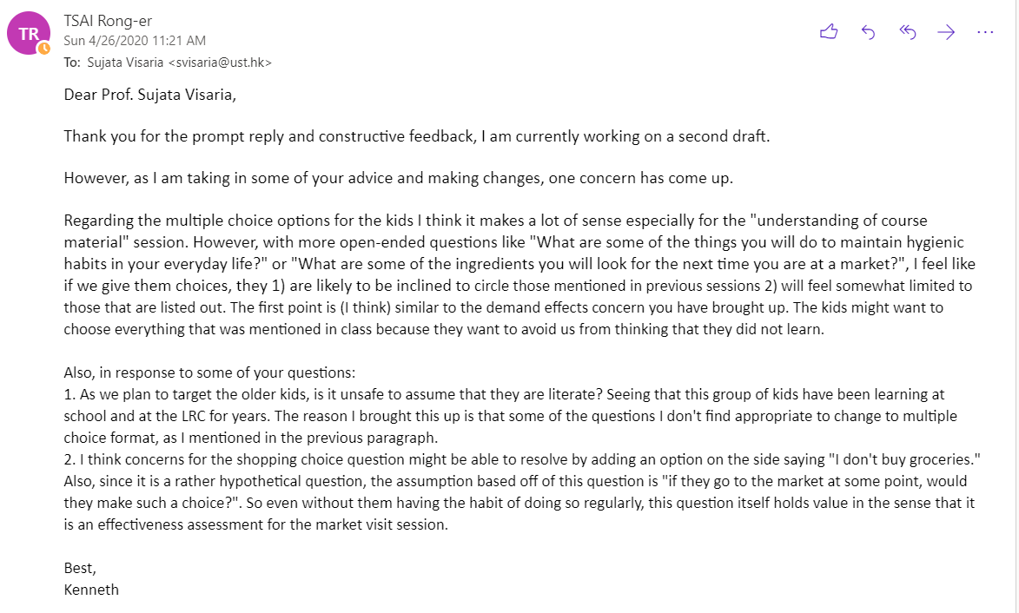

2nd feedback (from Apr. 26):

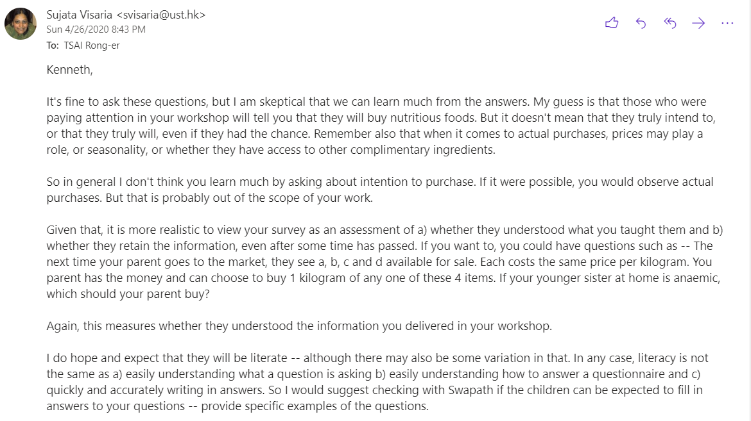

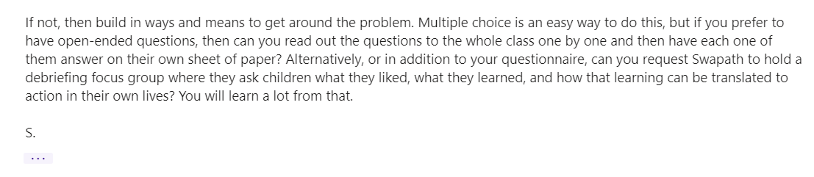

Our up-to-date third draft of post-assessment survey, after feedback:

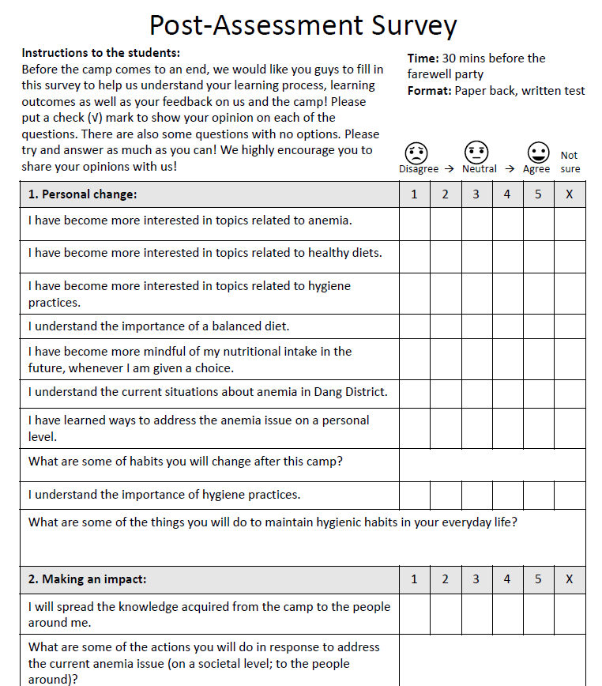

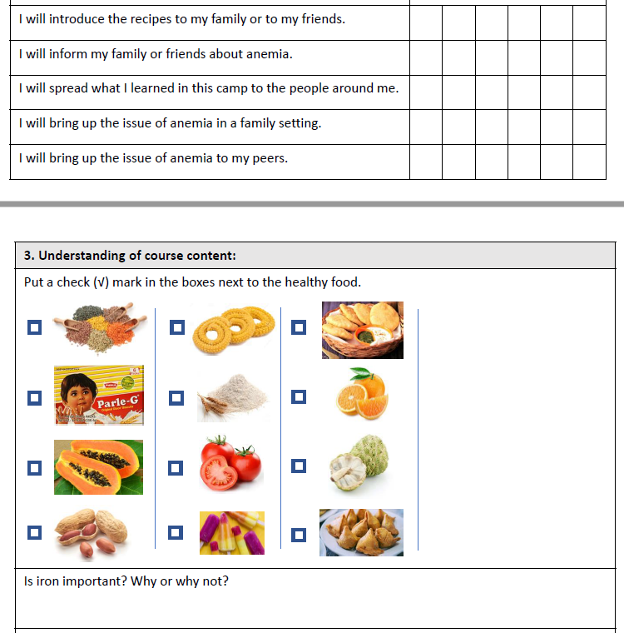

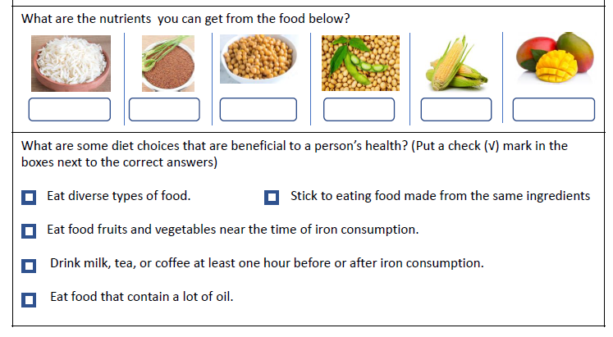

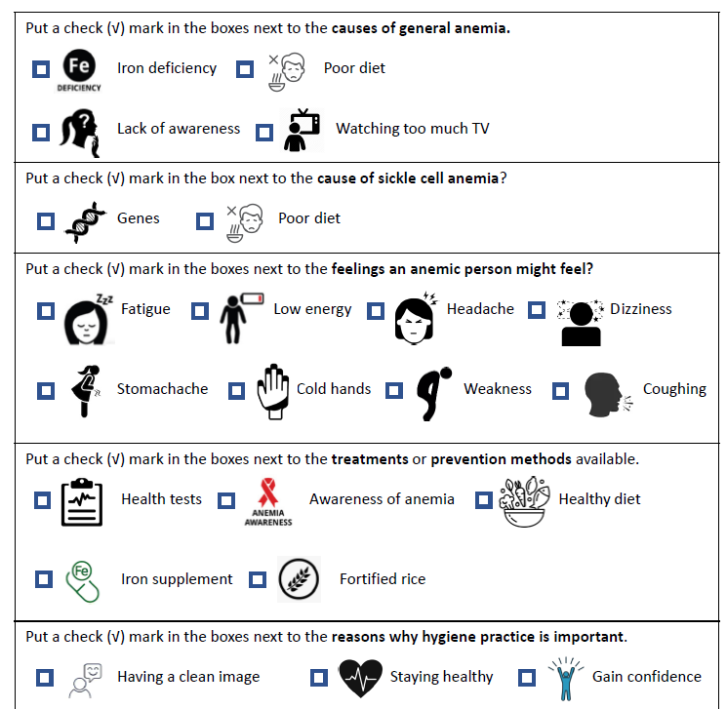

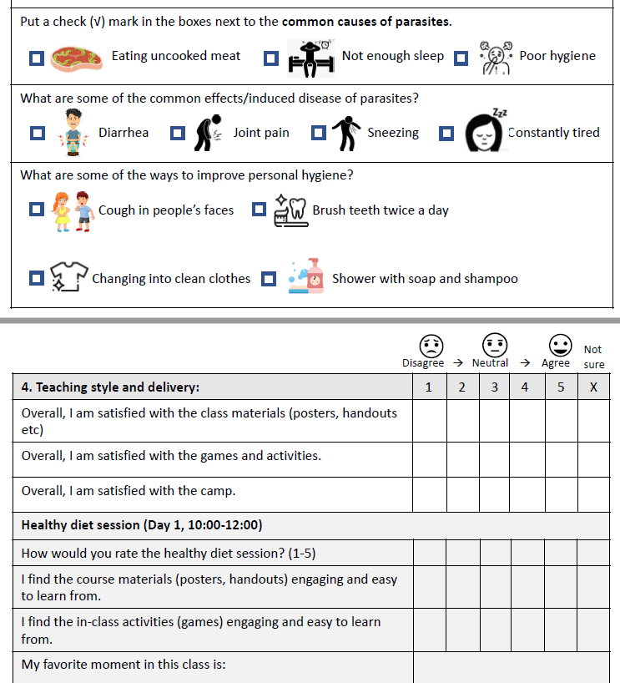

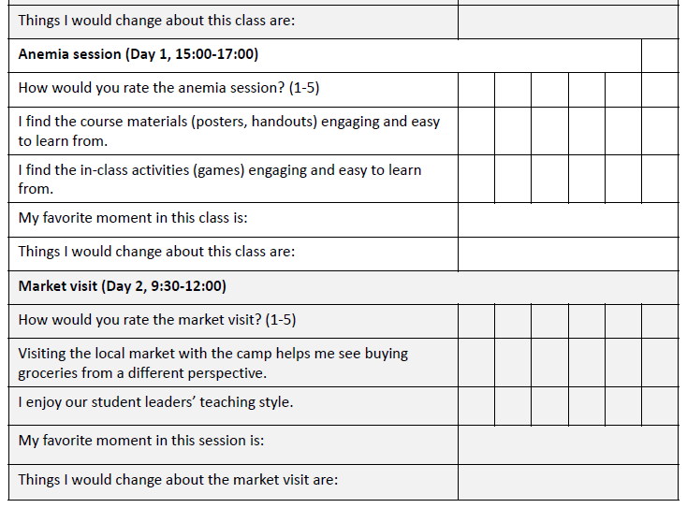

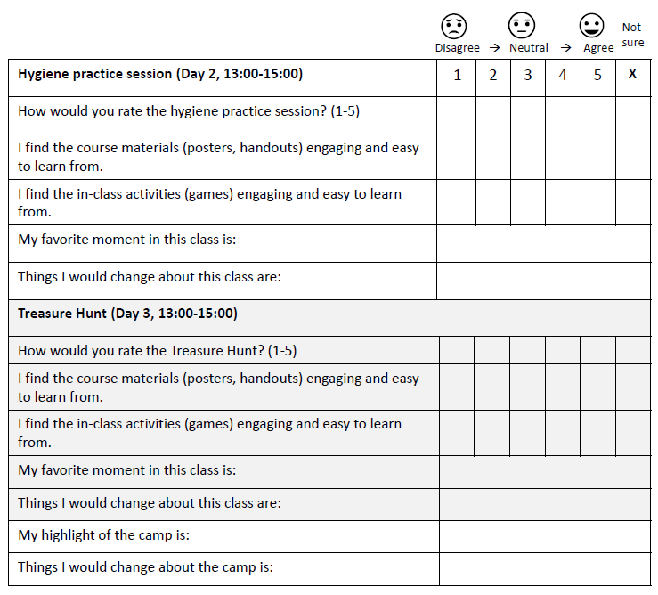

2.4 Feedback from partners:

This is a very essential part for our project since the very beginning of our project, as Dang district is a very special region. Much of the information specific to their local situations are unable to be obtained online, and so starting from the very beginning of the project, we have had to inquire a lot of information from our local connection, Mr. Rajesh Bhat.

(Mar. 16): local situation inquiry and feasibility check

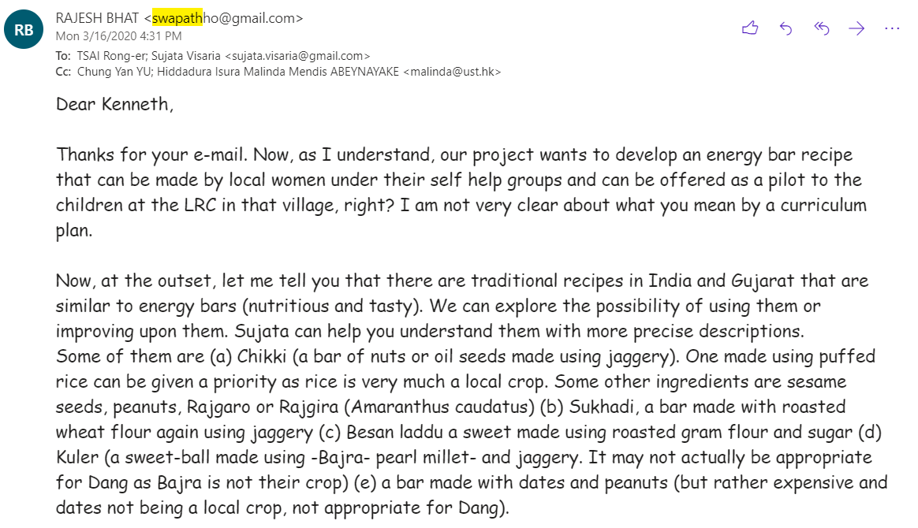

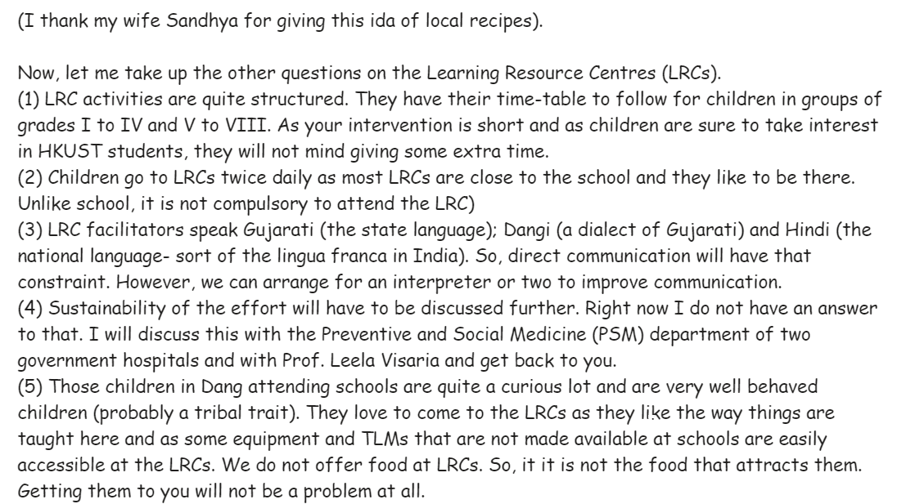

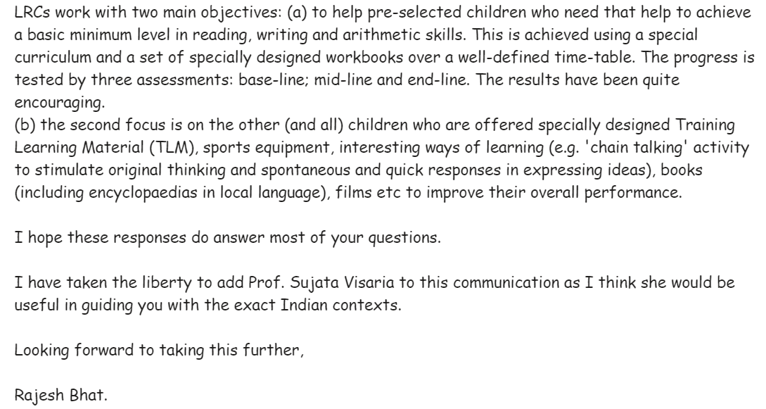

(Apr. 2): Further information

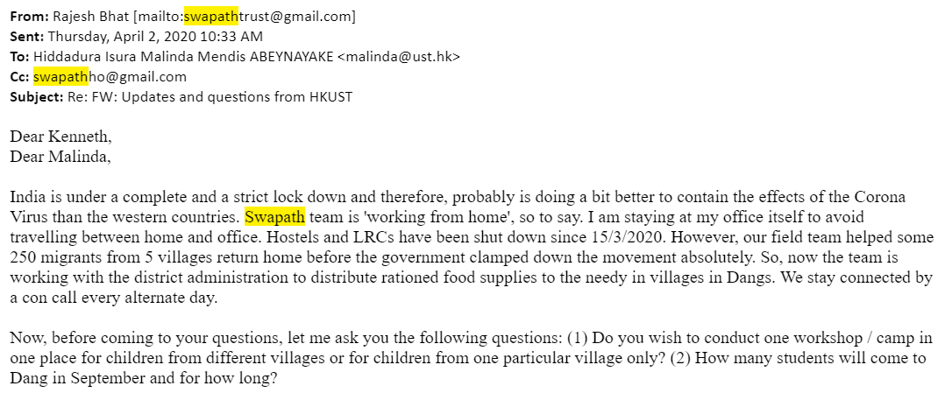

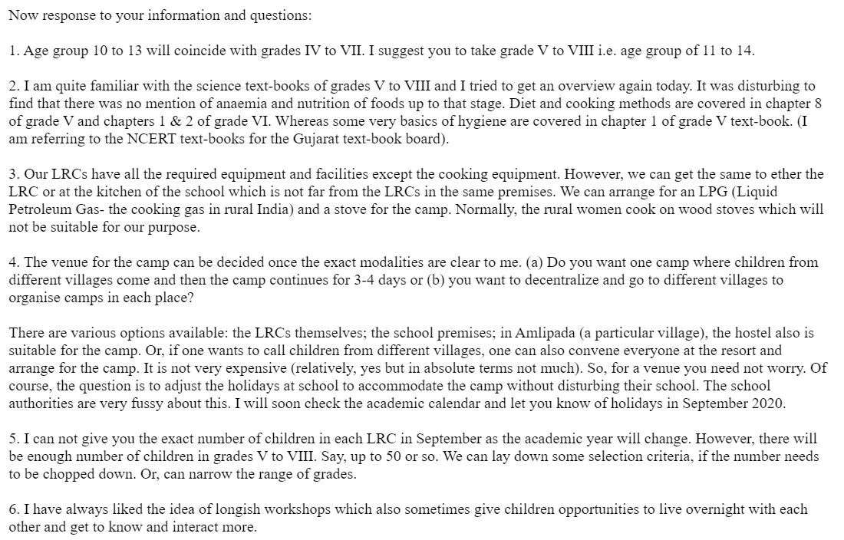

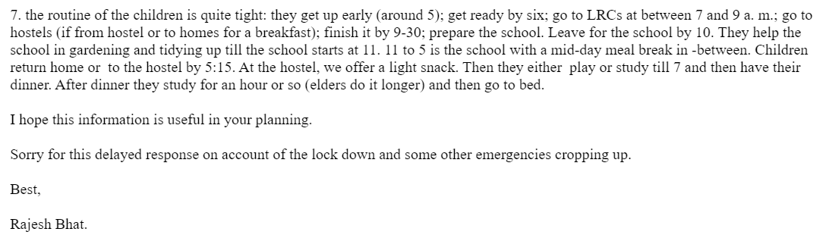

(May. 7)

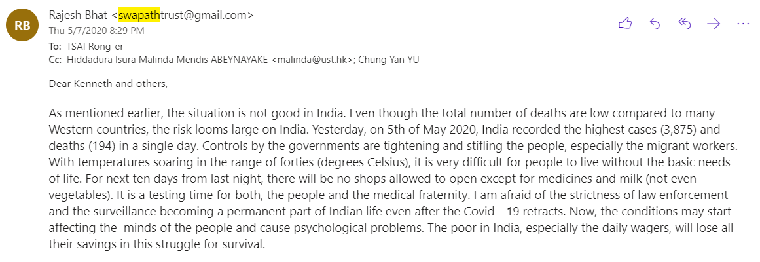

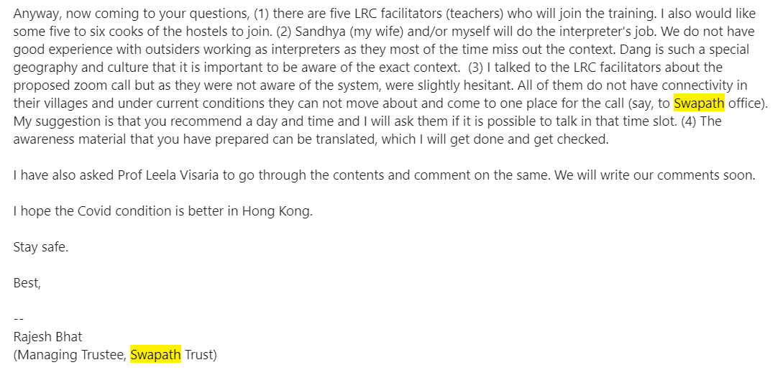

(May 17)

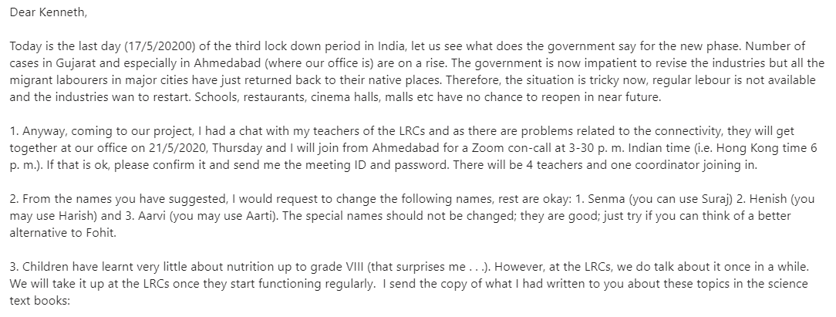

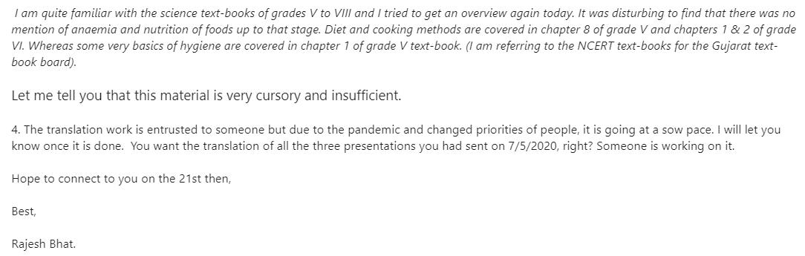

3. Future plans

3.1 Plans to do user testing and obtain feedback

1. **Prototyping: community center**

To figure out the potential flaws in our project and make it even more feasible, we plan to test out our program this summer by dividing it into separate sections. We will seek cooperation with a local community center (SSPEHTC) in HK via our member Lisa’s connection.

Lisa in the Education team will be the main facilitator in Hong Kong. Whilst other team members would serve as the teacher overseas. The classes will be run online via Zoom. We target 1-10 kids at once (grade 6-9) for a trial run, 10-30 kids for simulation. SSPEHTC would be able to help with the recruitment. During the class, students will sit within the coverage of the webcam. The real-life teaching will be projected on a bigger screen borrowed from the center. Lisa (and perhaps staff) will help in distributing and taking care of any teaching materials needed.

Community center facebook page: <https://www.facebook.com/SSPEHTC/>

1. **Local, culturally appropriate narratives: local partner Mr. Rajesh Bhat and his team in Swapath Trust**

Our team has been connecting with Mr. Rajesh Bhat over the last few months. We have been updating him (approximately) bi-weekly, and we will continue to do so. At this moment, he is reviewing many of our curriculum plans and materials, and we can expect to receive his feedback anytime now. The plan this summer is to continuously work on our materials according to the feedback received from the local partner(s). We aim to make it not only most effective in terms of learning experience, but also fitting for the local context.

1. **Recipe/food-making sessions feedback**

The preference of the recipes is very local and personal. We have cooked these recipes and asked for comments from friends and family. It is testified that the recipes are of our liking, but we have no idea if it is the same for locals. In this summer, it is essential to reach out to as many people from similar cultures like that of Dang District as we can (potentially some of our Indian friends) for gaining an understanding of local appetites. We can start with students on campus, of other universities or even Indian organizations in Hong Kong if needed. We aim to make the recipes closer to what the locals find to be tasty.

3.2 Future plans

**Short-term plans (summer):**

* Refine the recipe and have the flavor tested out by people to ensure quality
  + For the selected recipes, look out on different variations based on more accurate research of local market price, domestic income and preference of the district
  + Collect information from Mr. Rajesh and the Internet to understand more about local eating habits and taboos. Design additional modified recipes from the analyzed information
  + Reach out to Indian friends or students on campus or in other universities to taste the food we prepared and ask for comments of cooking details and preferences
* Connect with the local government and/or other NGOs through PATH:
  + Work out the preliminary arrangements: PATH has promised to help us connect in the last meeting and we have been in touch since then. So far we have sent in some of our documents introducing our goals and efforts.
  + Modify the curriculum according to the new connections and new plans:
    - As PATH promised to try and connect us with the local government, chances are we will have to adjust our content/delivery according to the best interest for the program in terms of sustainability.
* Test out the curriculum, food making sessions as well as all other activities
  + Conduct mock sessions with local communities and personal connections
  + Run through everything and refine the entire camp at least three times

**Long-term: focus on sustainability**

* Conduct the camp in Dang District in September
  + Receive feedback, improve and modify plans and recipes from first-hand experiences
  + Analyze the data collected from the assessments, adjust the recipes accordingly
* Keep up with the connections
  + Swapath, PATH, local government and others: negotiate further terms of arrangements for the future development of the program
  + Reach out for more connections
* Get in touch with NGOs in Gujarat (e.g. Gram Vikas Trust & Samerth Charitable Trust) to seek for expansion of the project

3.3 Timeline for the coming months

Summer timeline: (Subject to change depending on the availability of the continuing members)

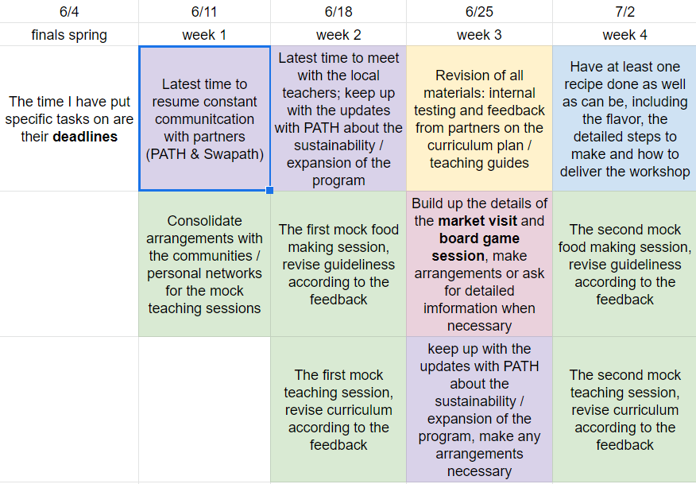

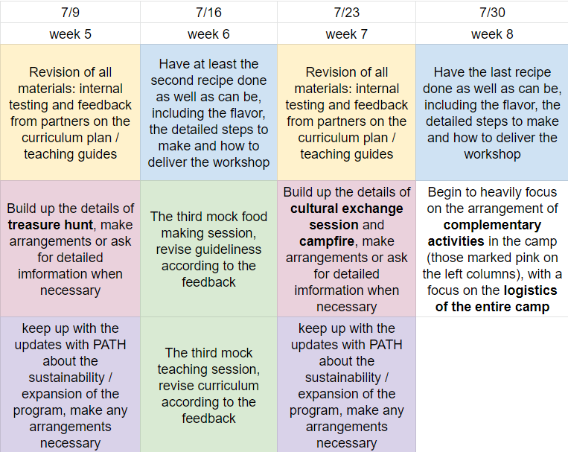

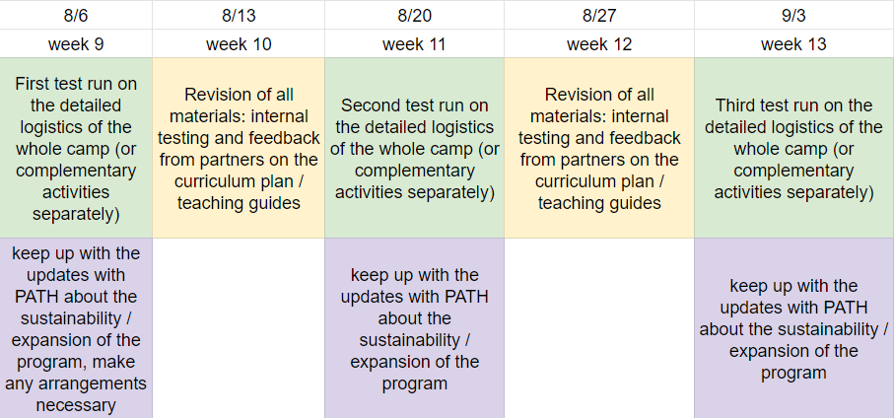

3.4 Program execution, training and maintenance

**Execution plans**

* Solidify curriculum by summer by constantly receiving feedback from partners, advisors mock sessions arranged by our team.
* Implement our plan in September when we are allowed to fly over to Dang District
* We will teach the local teachers to deliver the curriculum. At the same time, Mr. Rajesh (and perhaps his wife Sandhya too) will be in charge of the translation. We have ensured the translator is up to date with our progress and we are constantly receiving feedback and suggestions from his side.

**Training**

* For us:
  + Familiarize with the details of the execution of each curriculum by arranging constant mock sessions. We have started our first one last Friday, and we will arrange approximately 6 more mock sessions to go through everything that we need, while modifying the curriculum in between as needed
* For the local teachers:

1. Connection in advance, get everyone on board and fully understanding of the contents long before our arrival.
2. Upon arrival, we will arrange face to face sessions with the teachers in advance of the camp
3. During the camp, we have arranged a special session in order for us to review the process. If anything doesn’t go as planned despite our long-in-advance preparation and backup plans, this is also the time to come up with more contingency plans with the teachers.

1. US National Institute of Health. (2020, 28 Feb). Iron. <https://ods.od.nih.gov/factsheets/Iron-HealthProfessional/>